จะต้อง run java ก่อนถึงจะ compile โค้ดได้

การใช้ openjdk-8-jdk จะง่ายเพราะไม่ต้องเซต path

การใช้ xamp on linux

<http://www.wikihow.com/Install-XAMPP-on-Linux>

**sudo /opt/lampp/lampp start**

cd /opt/lampp/htdocs/JUDGE-master/codejudge-compiler/src

javac codejudge/compiler/*.java

java codejudge.compiler.CodejudgeCompiler

การใช้ Tmux แยก session

<https://narongdej.sarnsuwan.com/blog/2016/06/29/how-to-use-tmux-to-switch-between-programs-in-one-terminal/>

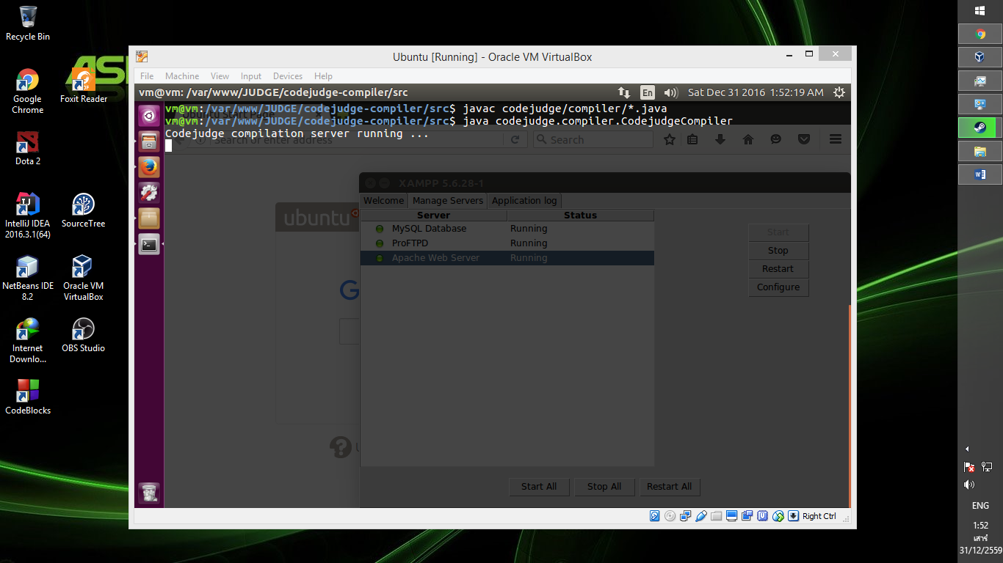

Chang permisstion

find /opt/lampp/htdocs -type d -exec chmod 755 {} \;

**clear ล้างจอ**

**Login Root**

sudo passwd root

su root

# [How to get a colored bash?](https://askubuntu.com/questions/517677/how-to-get-a-colored-bash)

I came up with this solution:

* open ~/.bashrc in an editor
* copy this and add it at the end of .bashrc file:

PS1='\[\033[1;36m\]\u\[\033[1;31m\]@\[\033[1;32m\]\h:\[\033[1;35m\]\w\[\033[1;31m\]\$\[\033[0m\] '

* save the file and restart bashrc:

source ~/.bashrc

For a full list of available colors and further options look up these links:

# [How to install OpenJDK 8 on 14.04 LTS?](https://askubuntu.com/questions/464755/how-to-install-openjdk-8-on-14-04-lts)

**JDK**

sudo apt-get install openjdk-8-jdk

**JRE**

sudo apt-get install openjdk-8-jre

### **Old Update**

I found two repository but I do not recommend

* OpenJDK builds (all archs)

ppa:openjdk-r/ppa

* OpenJDK 8 backport for trusty

ppa:jochenkemnade/openjdk-8